**DAILY ONLINE ACTIVITIES SUMMARY**

|  |  |  |  |  |  |  |  |  |
| --- | --- | --- | --- | --- | --- | --- | --- | --- |
| **Date:** | **29/06/2020** | | | | | **Name:** | **PRANEETA P HANDRAL** | |
| **Sem & Sec** | **4​th​ SEM. & ‘B’ SEC.** | | | | | **USN:** | **4AL19CS401** | |
| **Online Test Summary** | | | | | | | | |
| **Subject** | | **_ _ _** | | | | | | |
| **Max. Marks** | | **30** | | **Score** | | | **_ _** | |
| **Certification Course Summary** | | | | | | | | |
| **Course** | **Introduction to Cloud** | | | | | | | |
| **Certificate Provider** | | | **Cognitive class** | | **Duration** | | | **6 Hrs.** |
| **Coding Challenges** | | | | | | | | |
| **Problem Statement:** Given a list of numbers, write a Python program to count Even and Odd numbers in a List.  Example: Input: list1 = [2, 7, 5, 64, 14] Output: Even = 3, odd = 2 Input: list2 = [12, 14, 95, 3] Output: Even = 2, odd = 2 | | | | | | | | |
| **Status:** **Executed.** | | | | | | | | |
| **Uploaded the report in Github** | | | | | **Yes** | | | |
| **If yes Repository name** | | | | | **LockdownCoding**  <https://github.com/praneetahandral/lockdowncoding> | | | |
| **Uploaded the report in slack** | | | | | **Yes** | | | |

**Online Test Summary:** No internals conducted.

**Online Certification course Summary​:** I have taken my Online Certification Course in **Cognitive class**  the course which I have opted is **Introduction to Cloud**. Course contains videos, tutorials, assessments and quiz. Today I have gone throw **Cloud Adoption and Emerging Technologies** and **Internet of Things in the Cloud.**

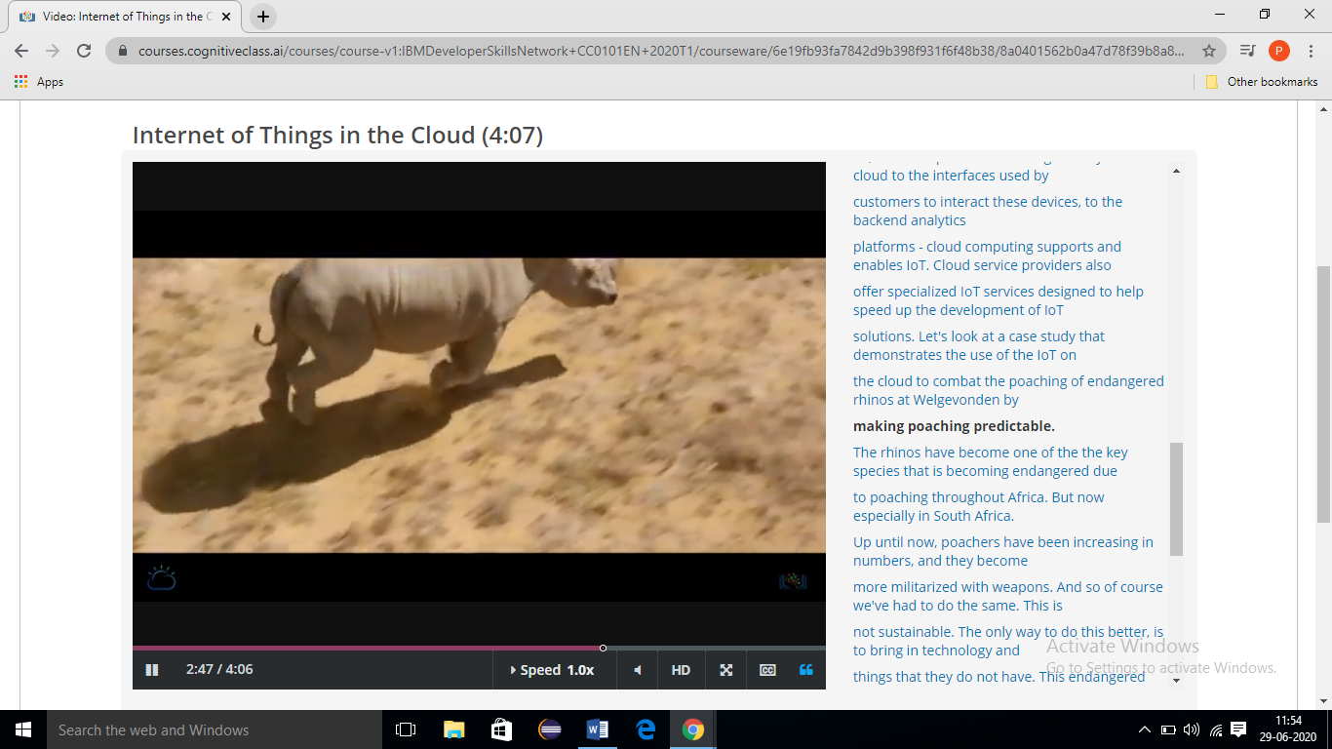

**Online Coding Summary​: Today I received one programs from prof. Vasudev CSE Dept I have written one program and uploaded it to my Github repository. This is my repository snapshot. I have uploaded the frequency program.**

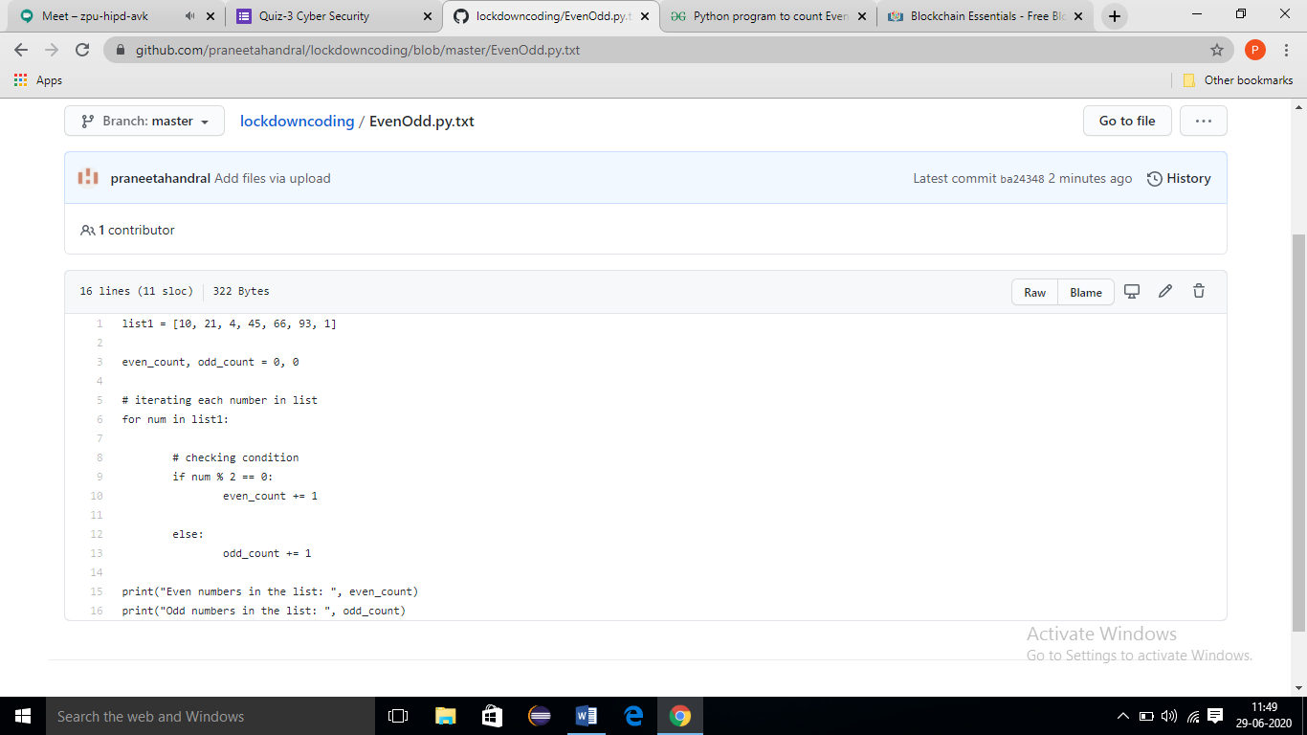

**Online Training**: Today I had attended the online training organized by CSE Dept AIET. The training was on **Cyber Security & Applications** done by Prof. Dr.ManjunathKotari CSE Dept. After the session there is two quiz was conducted. the snapshot that shown in below quiz attempted and the marks obtained.

